**SharePoint Overview(GE REN Finance DT)**

***---Atri Sengupta (223018839)***

Website Link : [CLICK](WEBSITE%20LINK:%20https:/spo-teamsite.ge.com/sites/RENCashAuto1)

SharePoint is available free within GE and comes along with Microsoft 360. One needs to request access to get it enabled. It normally takes 30-40 mins at maximum to get the site URL: [New item (ge.com)](https://spo-teamsite.ge.com/Lists/SiteDirectory/NewForm.aspx?Source=/SitePages/ThankYou.aspx).

**User Friendly**: SharePoint is good for teams who do not wish to code from scratch. Not all teams are oriented to web development and have expertise in the domains. Custom site development involves a steep learning curve. I have created a separate documentation on how to go by custom website development path. **Click here to access:** **C:\Users\223018839\Desktop\word\WEB DEVELOPMENT LEARNING CURVE.pdf**

**Post going through this learning curve, the issues of SSO integration, hosting and getting a GE domain name will still persist. SharePoint provides with inbuilt SSO integration, hosting and domain name and everything without recurring cost; much like how it was for WordPress installation in other GE divisions, thus becoming the best option for us**

**1. There are 2 versions of SharePoint sites**

**1. Classic**

**2. Modern.**

The recent sites(low in numbers) are all Modern sites. Most of sites created via SharePoint in GE are Classic sites.

**2. So what is the difference?**

Classic sites allowed customisation and hard coding. Its not something we can have for the modern pages. Thus we neither make changes to look and feel nor edit template. CSS code cannot be edited.

**3. Can the code be imported from SharePoint to Visual studio code?**

No. Its restricted. One can only inspect the code to understand what’s behind. Importing to editor is not allowed. SharePoint online as it was delivered in GE is as Out of the box mode which means that it only has standards feature. GE delivers site collection level of permission that allow you to customize your site with what’s available by default (**Today no customization are set at the tenant level**).

**4. Customisation with subtle changes in pre-written code would be nice and code could have been edited to suite the requirements. So why discontinue classic and move to modern SharePoint?**

The long-term cost of supporting custom master pages and other custom structural elements is high. Custom branding can make it more costly for GE to apply upgrades and provide ongoing support.

**Please refer the below links for more clarity**

<https://docs.microsoft.com/en-us/sharepoint/dev/solution-guidance/sharepoint-site-branding-and-page-customization-solutions>

**5. Can we access SharePoint sites within GE to take reference?**

Most of sites in Site Directory are either blocked or not updated any more. For accessing the blocked sites, one needs to request access. I tried to request for a couple of them but got denied.

**So how to take reference, considering reference of SharePoint sites online isn’t appropriate since most of sites are classic sites and customization here is not possible in tenant level.( Tenant is the subscription that comes to us. Tenant level customisation means, the changes we can make to the platform made available to us).**

**There are few public sites in GE which we can access. Most of them are classic but provide good reference as to standards followed.**

Here are some sites that allow access to all GE employees:

<https://spo-teamsite.ge.com/sites/GPOTREScorecardsInfoHub>

<https://spo-teamsite.ge.com/sites/GrRND_Community/SitePages/Homepage.aspx>

<https://spo-teamsite.ge.com/sites/GPCTPContinuingTrainingProgram>

<https://spo-teamsite.ge.com/sites/DIGGEDigitalITSupportPortal/SitePages/Home.aspx>

<https://spo-teamsite.ge.com/sites/FieldCoreFieldServicesInfoHub> (this one is a Hub)

<https://spo-teamsite.ge.com/sites/GEDigital>

**6. Can the site background be changes and buttons made transparent as shown in some of the public site in GE:**

<https://spo-teamsite.ge.com/sites/fieldcore/SitePages/Home.aspx>

**There are 2 types of modern sites in SharePoint.**

1. **Team Site.**
2. **Communication Site.**

look on this for more info on type of sites:

<https://spo-teamsite.ge.com/SitePages/A-Guide-to-Recognising-Different-Site-Types-in-SharePoint-Online.aspx>

The background image can be changed in team sites, not in communication site.

Plus the site: <https://spo-teamsite.ge.com/sites/fieldcore/SitePages/Home.aspx> is a classic site and not modern. The top-down automated news scroller can serve as a what’s hot section but this is not a default feature, **FieldCore** bought /created a custom app to get this. They also use the classic design that allow them to deal with the Content Editor webpart, this type of feature is not recommend as Microsoft will probably deprecate it in the future and force user to move to the modern design. **Please refer the link for more detail:** [**FW ACTION REQUIRED Prepare your classic SharePoint site for modernization (1).msg**](FW%20ACTION%20REQUIRED%20Prepare%20your%20classic%20SharePoint%20site%20for%20modernization%20(1).msg)

**7. Why we went with Communication site?**

I felt communication site will better suite our need as compared to a team site.

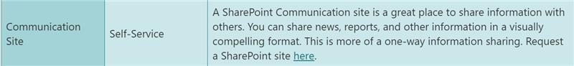

**8. When we right click on the buttons, option of “open link in new tab” isn’t coming. Instead its “open image in new tab”. Why?**

**I**t's because call to action block does not generate a <a href> tag. It is <src> if one checks the code behind, thus causing the option of open image on new tab when you right click. The code cannot be edited in modern pages, thus this cannot be changed.

*Web standard to open a link is left click. standard demands to open a new tab for a site that is not under the same domain of the triggering link. it's fine to keep the same tab if you go to another page of the site RENGERENFinanceDTCashAutomation1. Links pointing to elements within your site should be opened in the same tab with left click. it is just an assertion of simple Internet best practices:*

# *-----* Fernandes, Jose (GE Renewable Energy)

Lead Training Specialist

REN GS-SVS-Technology

**9. FAQ is not an in built feature provided in SharePoint. How to make it?**

I created it by using **list**.List allows you also (with the metadata) to create different view based on the same list. the list works like an excel sheet means you can use filter on each column.

So I created a new list and ticked the checkboxes based on what I want to show, what I do not want to show, how I want the list to look, grouped it by questions and saved it as default view to make it look like FAQ. **There is no documentation on it, I was playing with the buttons and I got it by trial and error.**

**10. How to make the site available for all GE employee?**

To allow all GE SSO employees to access the site, add the **Everyone except external users** group to the **Visitors** group of the SharePoint site. For more information look at

["Open your site to all GE SSO employees"](https://geit.service-now.com/kb_view.do?sysparm_article=GEKB2010759).

**11. How to shorten the SharePoint long URL?**

SharePoint online, as it was delivered in GE is as Out of the box mode which means that it only has standards feature. GE delivers site collection level of permission that allow you to customize your site with what’s available by default (**Today no customization are set at the tenant level**). Shortening URL is not an Out Of Box(OOB) feature in SP.

But there are other ways. The 2 ways I know, I have listed below **(2nd solution is the one to go to):**

**Method 1:**

There is an app called **ShortUrl.**

But it asks to get approval from tenant administrator, since GE has moved from classic to modern SP sites, I am not sure if this feature will get enabled, still I made the request and will let you know if it gets approved.

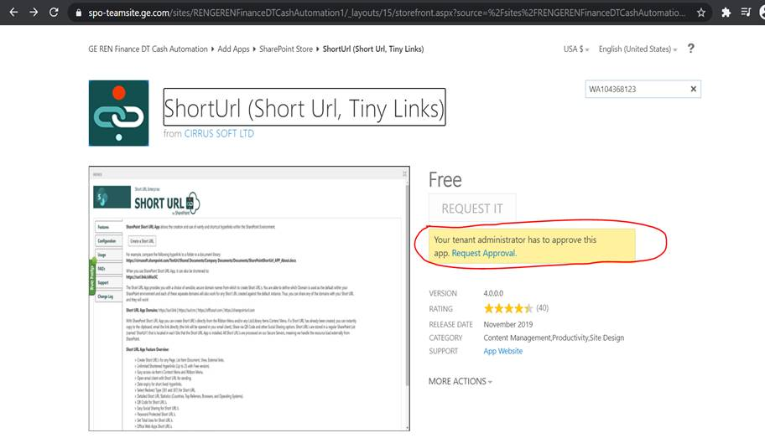

Link: <https://appsource.microsoft.com/en-us/product/office/wa104368123?tab=overview&signInModalType=2&ctaType=1>

**Method 2:**

**Rebrandly** comes with chrome extension that allows you to shorten URL. This is the easiest way to get things done without interference of administrator.

**Link :** [**https://support.rebrandly.com/hc/en-us/articles/115003983433-SharePoint-URL-Shortener**](https://support.rebrandly.com/hc/en-us/articles/115003983433-SharePoint-URL-Shortener)

<https://rebrand.ly/cashauto>  is the short URL I made for my website. Note that original URL will still be same. This short link redirects to the URL provided by SP team, but hope this serves the purpose.